*How to confirm shRNA sequences using BLAST* Created by Shanel Tsuda (8/28/2019)

Before you start:

* Make sure you have Python ver 2.7 downloaded
* Make sure you have the most up to date version of R and RStudio

1. Place all .seq files into a separate folder
2. Use < concSEQ.py > to combine all the .seq files into a single FASTA file.

* Double click the file, a GUI will open:

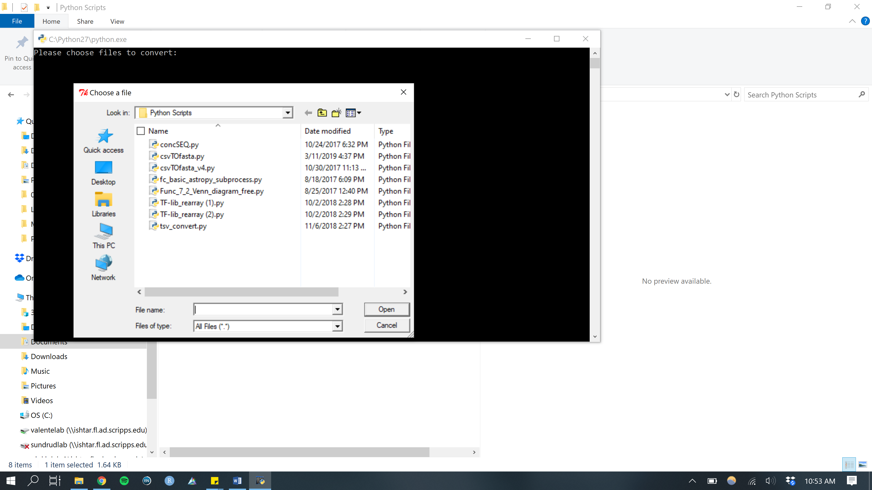

* Find the folder containing all the .seq files >> select all the .seq files >> click “Open”
* Python will begin loading the .seq files into the terminal. The names of all the .seq files will appear.

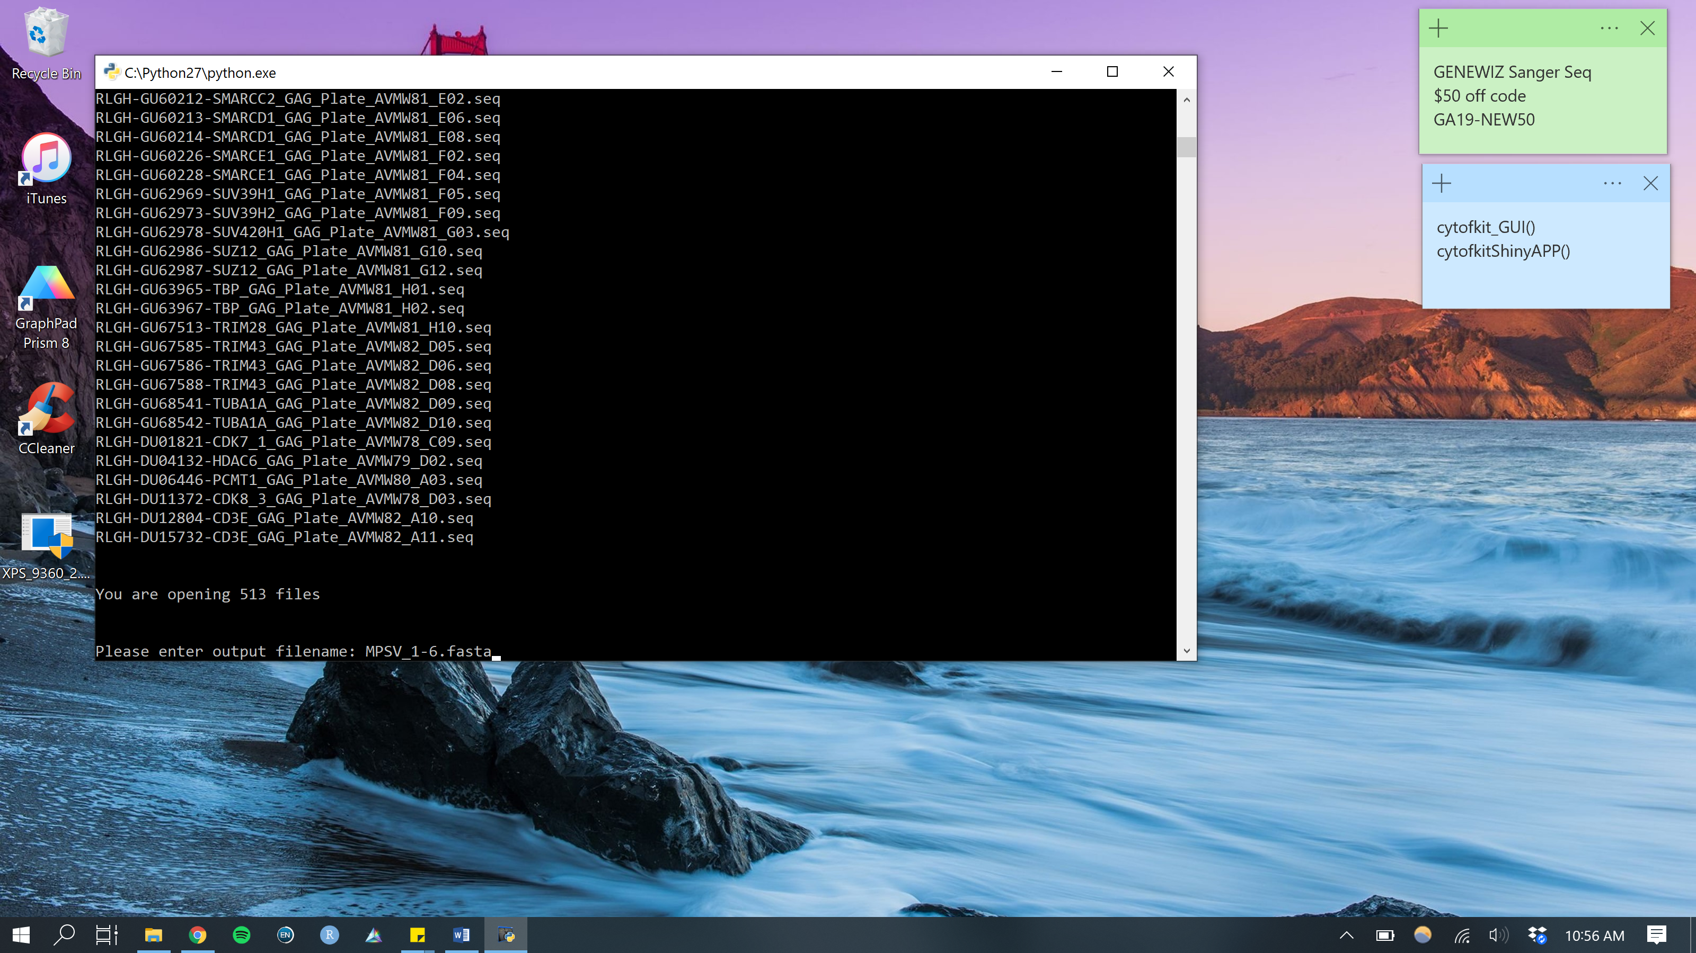

* Enter your desired filename. The name should be in this format: **filename.fasta** (don’t use spaces or special characters). Once you type in your filename, hit return/enter. The GUI will close.
* The new fasta file will be in the same folder as your .seq files. Check to make sure it was generated.

1. Use < csvTOfasta_v4.py > to convert your library file (.csv) to a FASTA file

* Double click the file, a GUI will open.
* Open the .csv file that contains the library you want to BLAST your sequences against.

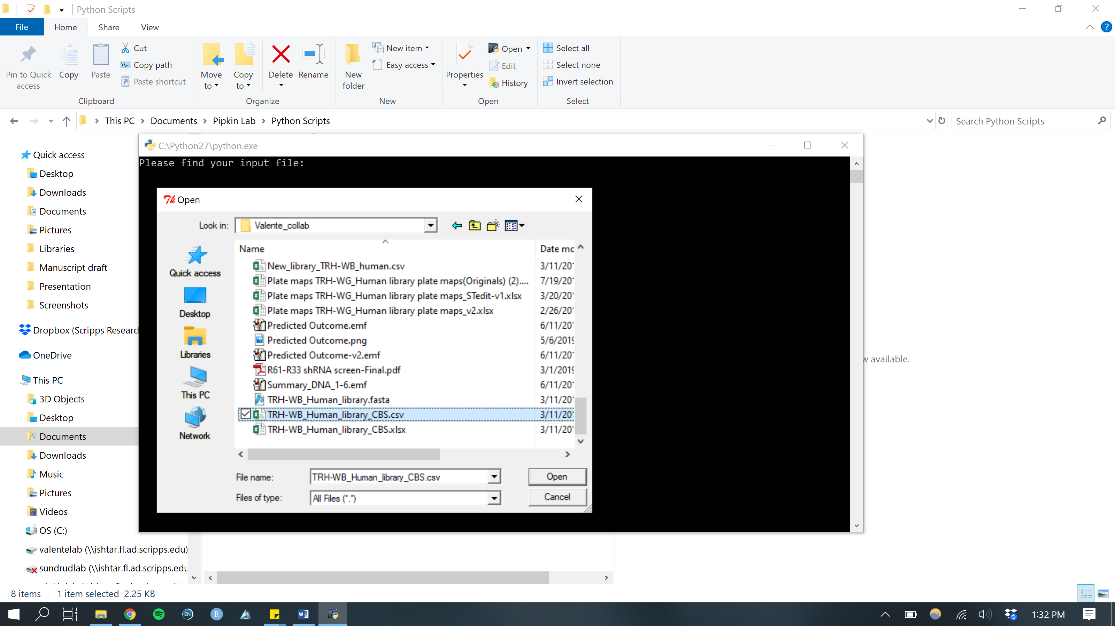

* Enter your desired filename. The name should be in this format: **filename.fasta** (don’t use spaces or special characters). Once you type in your filename, hit return/enter.

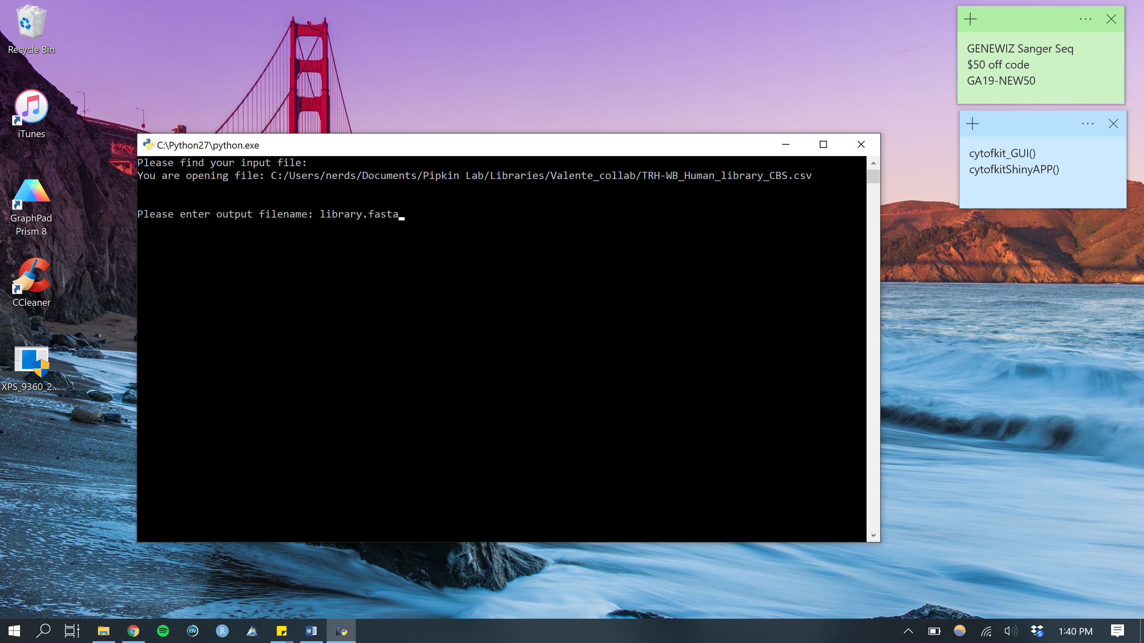

* Specify which column names you want to include in the fasta file. You need to at least include the clone ID, gene symbol, and sequence. For reference below is the first 5 lines of the library .csv file: included is the typical information needed for shRNA libraries: Plate ID, Plate position, Clone ID, Gene symbol, Gene ID, Sherwood Score, Sequence.

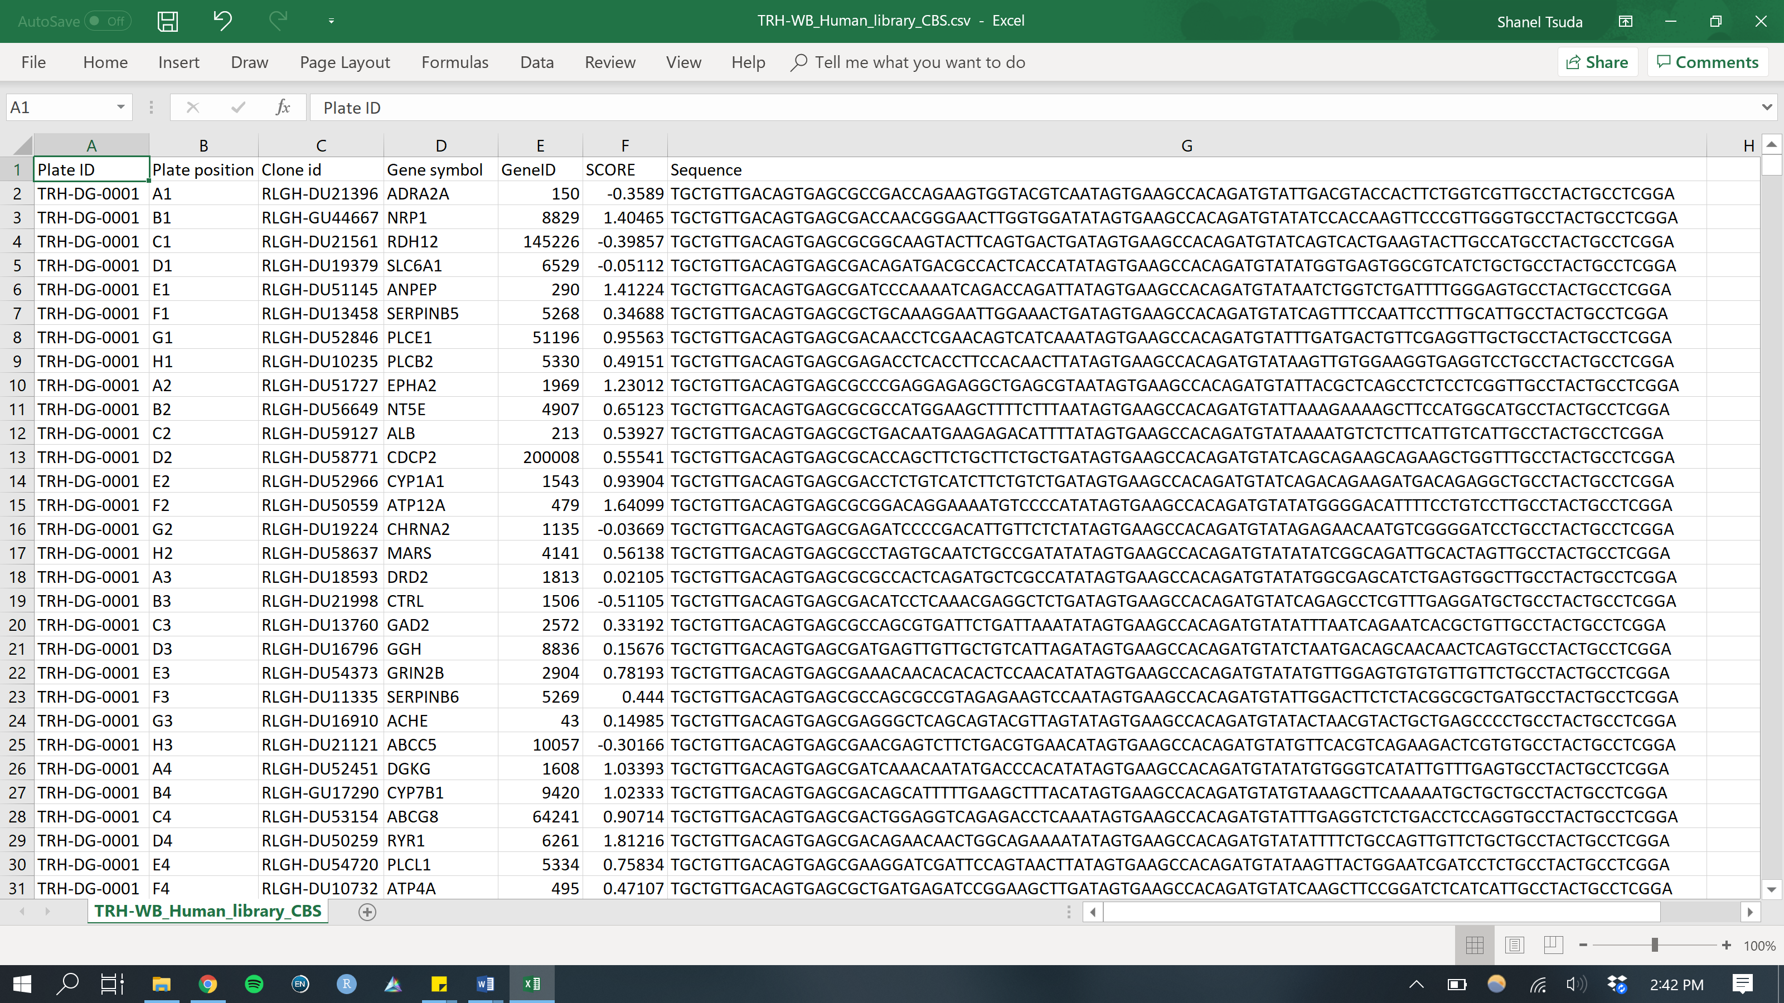

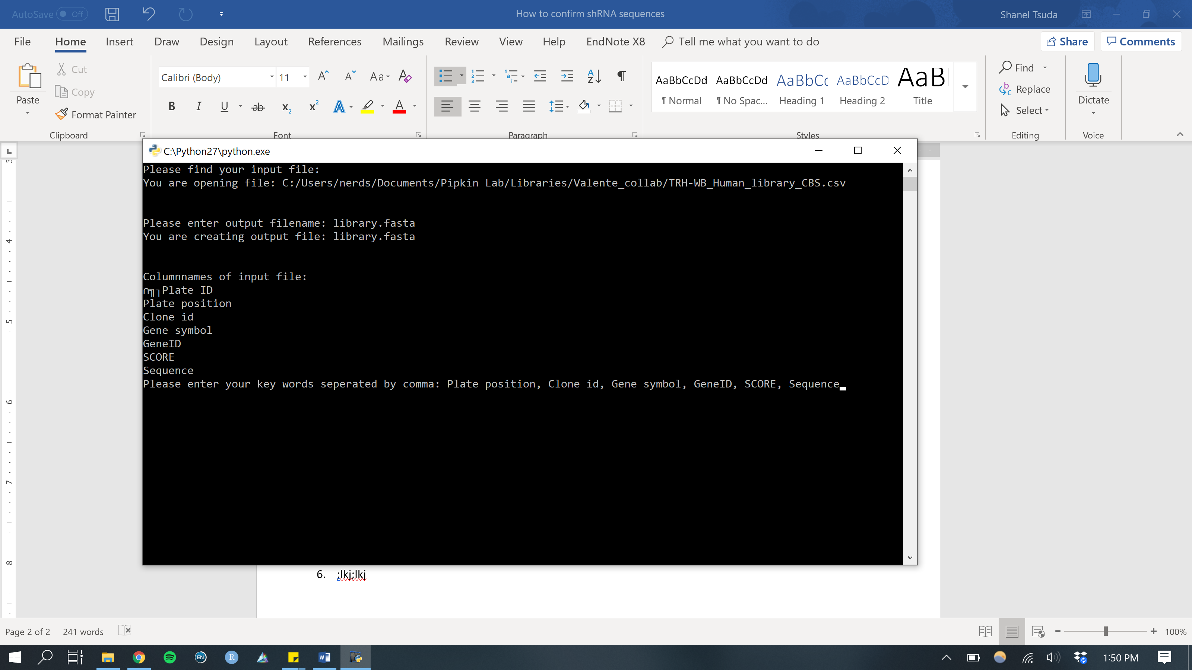

* noijiji

1. Open this link in your web browser: <http://10.1.1.62/blast/>. This is the site built for us by previous bioinformatics core members.

* *Database*: fasta file of the library you will BLAST the sequences against

*Sequences*: fasta file of the sequences you want to confirm

*Trim Sequences* (optional): fasta if there is a sequence you want to trim from either Database or Sequences, or both (I don’t typically use this)

*Trim* (optional): select to trim either Database or Sequences, or both

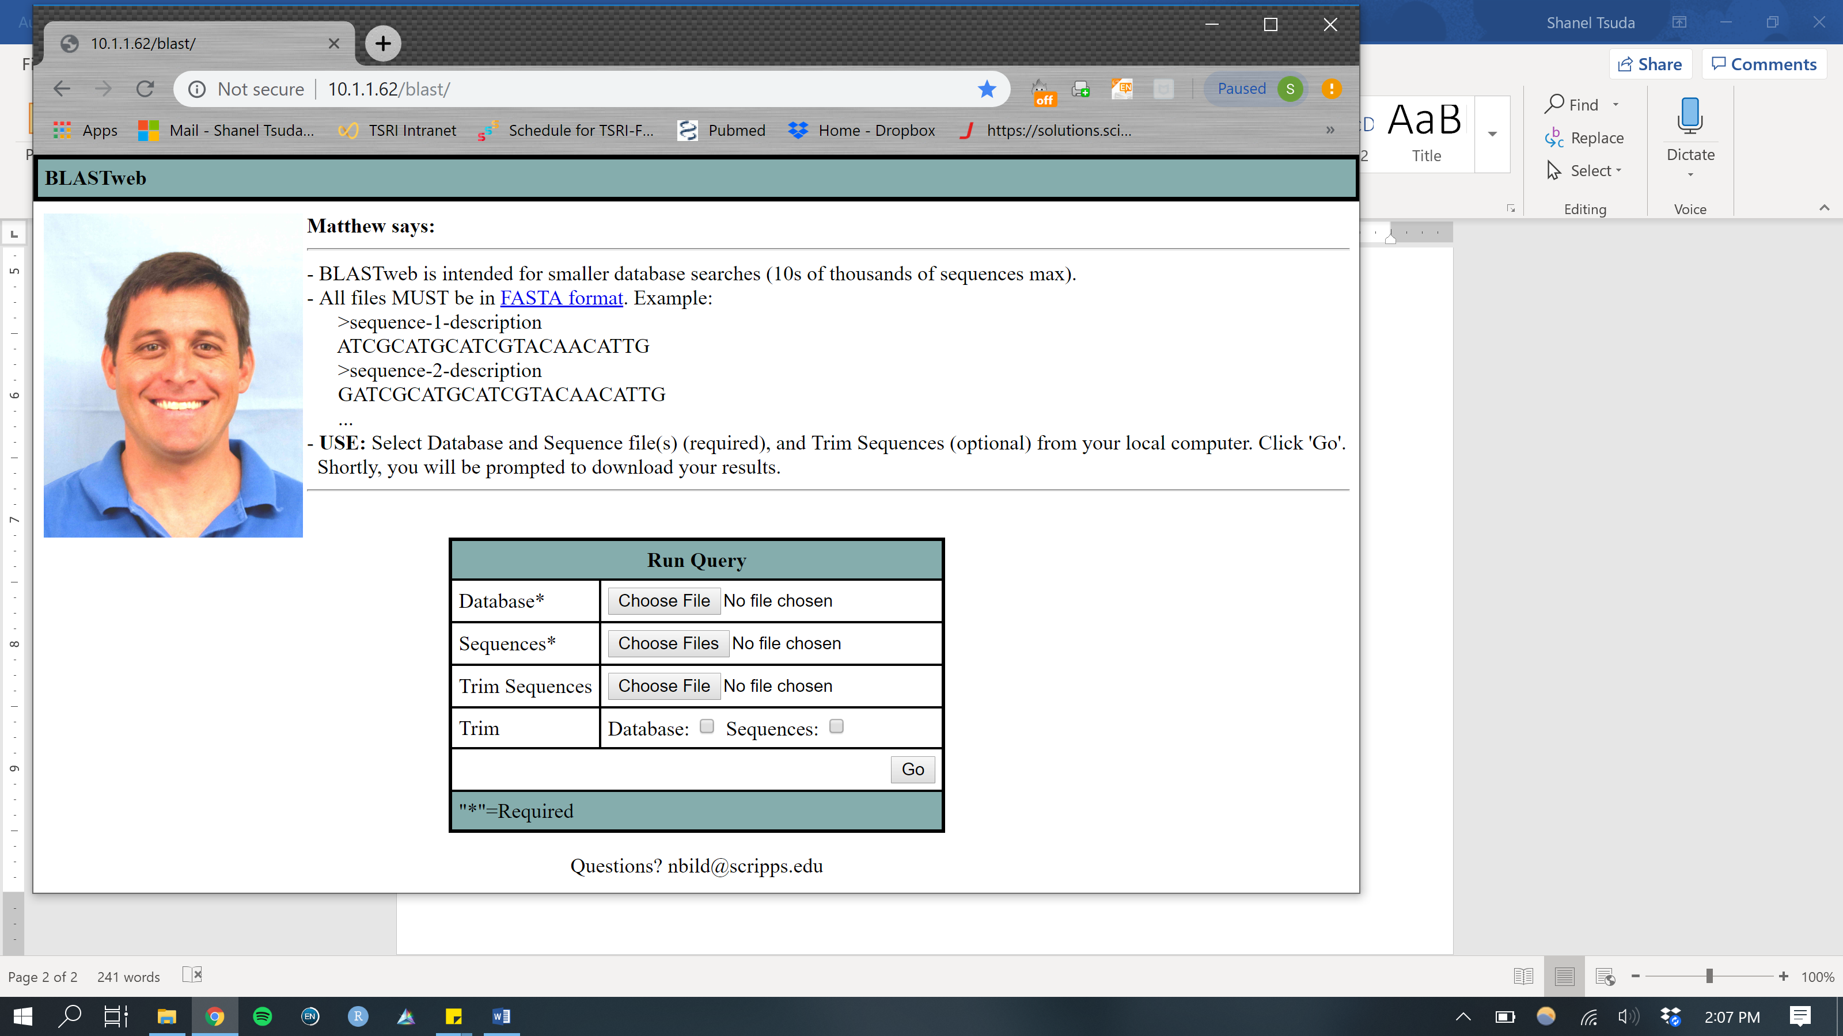

* Once you have uploaded your files, hit “Go.”
* If your run is successful, a .txt file will be downloaded. Select All and copy/paste into an Excel file. It should look like the table below. The .txt file will not have any column names, so you will have to add them in Excel.

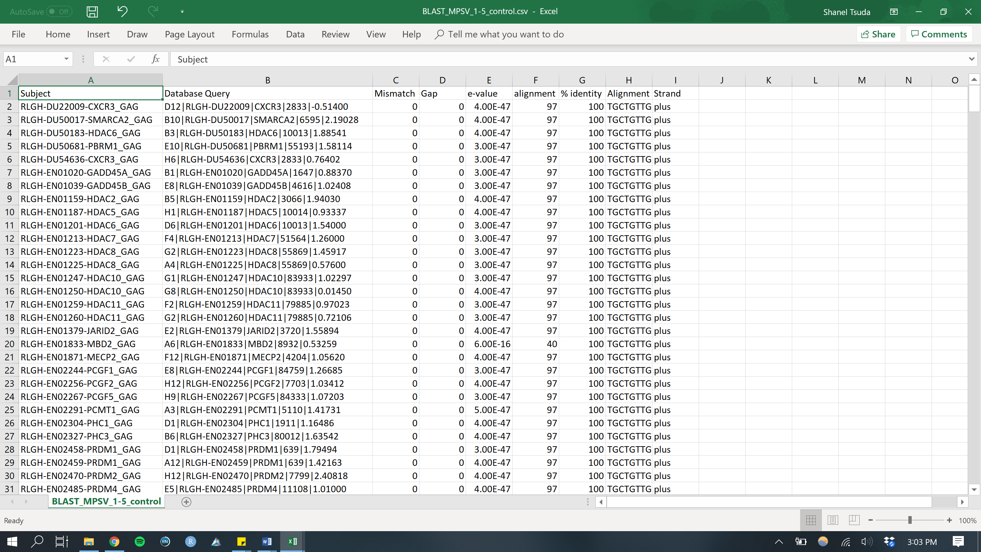

* *Subject*: the sequence name

*Database Query*: which sequence it matched to in the library

*Mismatch*: number of base pairs that did not match

*Gap*: number of base pairs that were not resolved

*e-value*: how meaningful the match was

*alignment*: number of base pairs that matched

*% identity*: what percent of the sequences matched

*Alignment*: sequence that aligned

*Strand*: plus or minus (positive/negative) DNA strand the sequence aligned to

1. Save your Excel file as a .csv
2. Follow the “shRNA_BLAST.Rmd” tutorial on how to confirm if your sequences matched correctly.